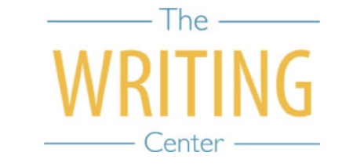 | 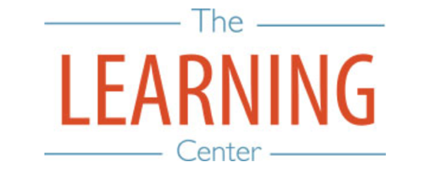

Summer Sessions I & II - 2024

Sunday Monday Tuesday Wednesday Thursday Friday Saturday
12 MAY | 13 | 14 | 15 SSI & Maymester Begin | 16 | 17 | 18
19 | 20 | 21 | 22 | 23 | 24 | 25
26 | 27 Holiday (Memorial Day) – No Classes | 28 | 29 | 30 Maymester Classes End/Exams | 31 Maymester Classes End/Exams | 1 JUNE
2 | 3 | 4 | 5 | 6 | 7 | 8
9 | 10 | 11 | 12 | 13 | 14 | 15
16 | 17 | 18 SSI Classes End | 19 Holiday (Juneteenth) – No Classes | 20 SSI Reading Day | 21 SSI Exam Day | 22 SSI Exam Day
23 | 24 SSII Begins | 25 | 26 | 27 | 28 | 29
30 | 1 JULY | 2 | 3 | 4 Holiday (Fourth of July) – No Classes | 5 | 6
7 | 8 | 9 | 10 | 11 | 12 | 13
14 | 15 | 16 | 17 | 18 | 19 | 20
21 | 22 | 23 | 24 | 25 SSII Classes End | 26 SSII Reading Day | 27
28 | 29 SSII Exam Day | 30 SSII Exam Day | 31 | 1 AUGUST | 2 | 3
4 | 5 | 6 | 7 | 8 | 9 | 10
11 | 12 | 13 | 14 | 15 | 16 | 17

The Writing & Learning Center / The University of North Carolina at Chapel Hill / writingcenter.unc.edu / learningcenter.unc.edu

