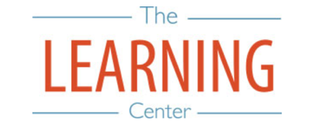
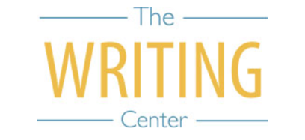

Fall Semester 2023

Sunday Monday Tuesday Wednesday Thursday Friday Saturday
6 AUGUST | 7 | 8 | 9 | 10 | 11 | 12
13 | 14 | 15 | 16 | 17 | 18 | 19
20 | 21 Classes Begin | 22 | 23 | 24 | 25 | 26
27 | 28 | 29 | 30 | 31 | 1 SEPTEMBER | 2
3 | 4 Holiday (Labor Day) | 5 Well-Being Day | 6 | 7 | 8 | 9
10 | 11 | 12 University Day (No classes held during ceremony) | 13 | 14 | 15 | 16
17 | 18 | 19 | 20 | 21 | 22 | 23
24 | 25 Well-Being Day | 26 | 27 | 28 | 29 | 30
1 OCTOBER | 2 | 3 | 4 | 5 | 6 | 7
8 | 9 | 10 | 11 | 12 | 13 | 14
15 | 16 | 17 | 18 | 19 Fall Break Begins | 20 Fall Break | 21 Fall Break
22 Fall Break | 23 Classes Resume at 8AM | 24 | 25 | 26 | 27 | 28
29 | 30 | 31 | 1 NOVEMBER | 2 | 3 | 4
5 | 6 | 7 | 8 | 9 | 10 | 11
12 | 13 | 14 | 15 | 16 | 17 | 18
19 | 20 | 21 | 22 Thanksgiving Recess | 23 Thanksgiving Recess | 24 Thanksgiving Recess | 25 Thanksgiving Recess
26 Thanksgiving Recess | 27 Classes Resume at 8AM | 28 | 29 | 30 | 1 DECEMBER | 2
3 | 4 | 5 | 6 Classes End | 7 Reading Day | 8 Exams | 9 Exams
10 | 11 Exams | 12 Exams | 13 Reading Day | 14 Exams | 15 Exams | 16

The Writing & Learning Center / The University of North Carolina at Chapel Hill / writingcenter.unc.edu / learningcenter.unc.edu

