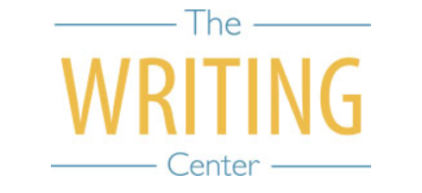 | 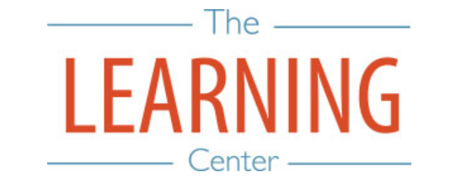

Summer Sessions I & II - 2023

Sunday Monday Tuesday Wednesday Thursday Friday Saturday
14 MAY | 15 | 16 | 17 SSI & Maymester Begin | 18 | 19 | 20
21 | 22 | 23 | 24 | 25 | 26 | 27
28 | 29 Holiday – No Classes | 30 | 31 | 1 JUNE Maymester Classes End/Exams | 2 Maymester Class End/Exams | 3
4 | 5 | 6 | 7 | 8 | 9 | 10
11 | 12 | 13 | 14 | 15 | 16 | 17
18 | 19 Holiday – No Classes | 20 SSI Classes End | 21 SSI Reading Day | 22 SSI Exam Day | 23 SSI Exam Day | 24
25 | 26 SSII Begins | 27 | 28 | 29 | 30 | 1 JULY
2 | 3 | 4 Holiday – No Classes | 5 | 6 | 7 | 8
9 | 10 | 11 | 12 | 13 | 14 | 15
16 | 17 | 18 | 19 | 20 | 21 | 22
23 | 24 | 25 | 26 | 27 SSII Classes End | 28 SSII Reading Day | 29
30 | 31 SSII Exam Day | 1 AUGUST  SSII Exam Day | 2 | 3 | 4 | 5
6 | 7 | 8 | 9 | 10 | 11 | 12
13 | 14 | 15 | 16 | 17 | 18 | 19

The Writing & Learning Center / The University of North Carolina at Chapel Hill / writingcenter.unc.edu / learningcenter.unc.edu

