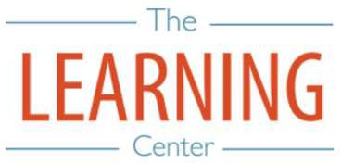
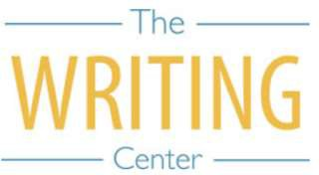
Spring Semester 2023

Sunday Monday Tuesday Wednesday Thursday Friday Saturday

8 JANUARY | 9 Classes begin | 10 | 11 | 12 | 13 | 14
15 | 16 Holiday MLK Day | 17 | 18 | 19 | 20 | 21
22 | 23 | 24 | 25 | 26 | 27 | 28
29 | 30 | 31 | 1 FEBRUARY | 2 | 3 | 4
5 | 6 | 7 | 8 | 9 | 10 | 11
12 | 13 Well-Being Day | 14 Well-Being Day | 15 | 16 | 17 | 18
19 | 20 | 21 | 22 | 23 | 24 | 25
26 | 27 | 28 | 1 MARCH | 2 | 3 | 4
5 | 6 | 7 | 8 | 9 | 10 | 11
12 | 13 Spring Break begins | 14 Spring Break | 15 Spring Break | 16 Spring Break | 17 Spring Break | 18
19 | 20 Classes resume at 8AM | 21 | 22 | 23 | 24 | 25
26 | 27 | 28 | 29 | 30 | 31 | 1 APRIL
2 | 3 | 4 | 5 | 6 Well-Being Day | 7 Holiday | 8
9 | 10 | 11 | 12 | 13 | 14 | 15
16 | 17 | 18 | 19 | 20 | 21 | 22
23 | 24 | 25 | 26 | 27 | 28 Classes end | 29 Reading Day
30 | 1 MAY  Exam Day | 2 Exam Day | 3 Reading Day | 4 Exam Day | 5 Exam Day | 6 Reading Day
7 | 8 Exam Day | 9 Exam Day | 10 | 11 | 12 | 13
14 Spring Commencement | 15 | 16 | 17 | 18 | 19 | 20

The Writing & Learning Center / The University of North Carolina at Chapel Hill / writingcenter.unc.edu (919) 962-7710 learningcenter.unc.edu

