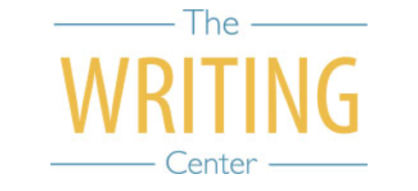 | 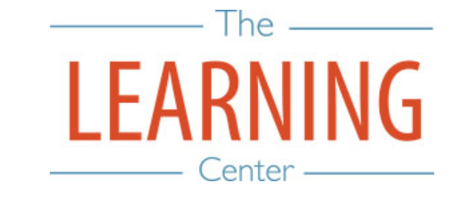

Summer Sessions I & II - 2022

Sunday Monday Tuesday Wednesday Thursday Friday Saturday
MAY | 9 | 10 | 11 SSI & Maymester Classes Begin | 12 | 13 | 14
15 | 16 | 17 | 18 | 19 | 20 | 21
22 | 23 | 24 | 25 | 26 Maymester Classes End | 27 Maymester Exams | 28
29 | 30 Holiday – No Classes | 31 | 1 JUNE | 2 | 3 | 4
5 | 6 | 7 | 8 | 9 | 10 | 11
12 | 13 SSI Classes End | 14 SSI Reading Day | 15 SSI Exam Day | 16 SSI Exam Day | 17 | 18
19 | 20 SSII Begins | 21 | 22 | 23 | 24 | 25
26 | 27 | 28 | 29 | 30 | 1 JULY | 2
3 | 4 Holiday – No Classes | 5 | 6 | 7 | 8 | 9
10 | 11 | 12 | 13 | 14 | 15 | 16
17 | 18 | 19 | 20 | 21 SSII Classes End | 22 SSII Reading Day | 23
24 | 25 SSII Exam Day | 26 SSII Exam Day | 27 | 28 | 29 | 30
31 | 1 AUGUST | 2 | 3 | 4 | 5 | 6
7 | 8 | 9 | 10 | 11 | 12 | 13

The Writing & Learning Center / The University of North Carolina at Chapel Hill / writingcenter.unc.edu (919) 962-7710 learningcenter.unc.edu

