 | Tasks for: ________________  (class) | Tasks for: ________________  (class) | Tasks for: ________________  (class) | Tasks for: ________________  (class) | Tasks for: ________________  (class)
Wed 4/27
Thurs 4/28
Fri 4/29
Sat 4/30
Sun 5/1
Mon 5/2
Tues 5/3
Wed 5/4
Thurs 5/5
Friday 5/6
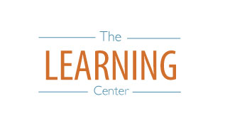
The Learning Center’s
Final Exam Master Task Table
Spring 2022
learningcenter.unc.edu https://www.facebook.com/uncwritingandlearning 919-962-7710

