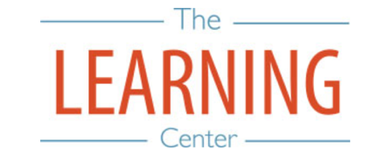
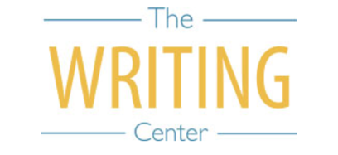

Fall Semester 2022

Sunday Monday Tuesday Wednesday Thursday Friday Saturday
7 AUGUST | 8 | 9 | 10 | 11 | 12 | 13
14 | 15 Classes begin | 16 | 17 | 18 | 19 | 20
21 | 22 | 23 | 24 | 25 | 26 | 27
28 | 29 | 30 | 31 | 1 SEPTEMBER | 2 | 3
4 | 5 Holiday (Labor Day) | 6 Well-Being Day | 7 | 8 | 9 | 10
11 | 12 | 13 | 14 | 15 | 16 | 17
18 | 19 | 20 | 21 | 22 | 23 | 24
25 | 26 Well-Being Day | 27 | 28 | 29 | 30 | 1 OCTOBER
2 | 3 | 4 | 5 | 6 | 7 | 8
9 | 10 | 11 | 12 | 13 | 14 | 15
16 | 17 | 18 | 19 | 20 Fall Break Begins | 21 Fall Break | 22 Fall Break
23 Fall Break | 24 Classes Resume at 8AM | 25 | 26 | 27 | 28 | 29
30 | 31 | 1 NOVEMBER | 2 | 3 | 4 | 5
6 | 7 | 8 | 9 | 10 | 11 | 12
13 | 14 | 15 | 16 | 17 | 18 | 19
20 | 21 | 22 | 23 Thanksgiving Recess | 24 Thanksgiving Recess | 25 Thanksgiving Recess | 26 Thanksgiving Recess
27 Thanksgiving Recess | 28 Classes Resume at 8AM | 29 | 30 Classes End | 1 DECEMBER Reading Day | 2 Exams | 3 Exams
4 | 5 Exams | 6 Exams | 7 Reading Day | 8 Exams | 9 Exams | 10
11 | 12 | 13 | 14 | 15 | 16 | 17

The Writing & Learning Center / The University of North Carolina at Chapel Hill / writingcenter.unc.edu (919) 962-7710 learningcenter.unc.edu

