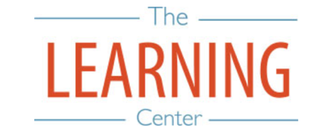
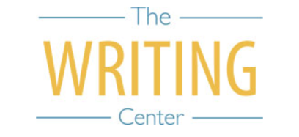

Spring Semester 2022

Sunday Monday Tuesday Wednesday Thursday Friday Saturday
2 JANUARY | 3 | 4 | 5 | 6 | 7 | 8
9 | 10 Classes begin | 11 | 12 | 13 | 14 | 15
16 | 17 Holiday  MLK Day | 18 | 19 | 20 | 21 | 22
23 | 24 | 25 | 26 | 27 | 28 | 29
30 | 31 | 1 FEBRUARY | 2 | 3 | 4 | 5
6 | 7 | 8 | 9 | 10 | 11 | 12
13 | 14 | 15 | 16 | 17 | 18 | 19
20 | 21 | 22 | 23 | 24 | 25 | 26
27 | 28 | 1 MARCH | 2 | 3 | 4 | 5
6 | 7 | 8 | 9 | 10 | 11 | 12 Spring Break begins
13 Spring Break | 14 Spring Break | 15 Spring Break | 16 Spring Break | 17 Spring Break | 18 Spring Break | 19 Spring Break
20 Spring Break | 21 Classes Resume at 8AM | 22 | 23 | 24 | 25 | 26
27 | 28 | 29 | 30 | 31 | 1 APRIL | 2
3 | 4 | 5 | 6 | 7 | 8 | 9
10 | 11 | 12 | 13 | 14 Wellness Day | 15 Holiday | 16
17 | 18 | 19 | 20 | 21 | 22 | 23
24 | 25 | 26 | 27 Classes End | 28 Reading Day | 29 Exams | 30 Exams
1 MAY | 2 Exams | 3 Exams | 4 Reading Day | 5 Exams | 6 Exams | 7
8 Spring Commencement | 9 | 10 | 11 | 12 | 13 | 14

The Writing & Learning Center / The University of North Carolina at Chapel Hill / writingcenter.unc.edu (919) 962-7710 learningcenter.unc.edu

