 | Tasks for: ________________  (class) | Tasks for: ________________  (class) | Tasks for: ________________  (class) | Tasks for: ________________  (class) | Tasks for: ________________  (class)
Wed 12/1
LDOC
Thu 12/2
Reading Day
Fri 12/3
Sat 12/4
Sun 12/5
Mon 12/6
Tue 12/7
Wed 12/8
Reading Day
Thu 12/9
Fri 12/10
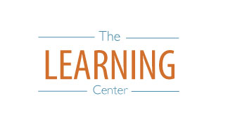
The Learning Center’s
Final Exam Master Task Table
Fall 2021
learningcenter.unc.edu https://www.facebook.com/uncwritingandlearning 919-962-3782

