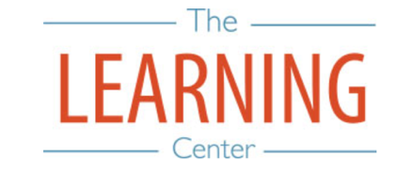
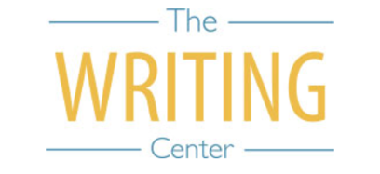

Fall Semester 2021

Sunday Monday Tuesday Wednesday Thursday Friday Saturday
8 AUGUST | 9 | 10 | 11 | 12 | 13 | 14
15 | 16 | 17 | 18 Classes begin | 19 | 20 | 21
22 | 23 | 24 | 25 | 26 | 27 | 28
29 | 30 | 31 | 1 SEPTEMBER | 2 | 3 | 4
5 | 6 Labor Day | 7 | 8 | 9 | 10 | 11
12 | 13 | 14 | 15 | 16 | 17 | 18
19 | 20 | 21 | 22 | 23 | 24 | 25
26 | 27 | 28 | 29 | 30 | 1 OCTOBER | 2
3 | 4 | 5 | 6 | 7 | 8 | 9
10 | 11 | 12 University Day | 13 | 14 | 15 | 16
17 | 18 | 19 | 20 | 21 Fall Break | 22 Fall Break | 23
24 | 25 Classes Resume at 8AM | 26 | 27 | 28 | 29 | 30
31 | 1 NOVEMBER | 2 | 3 | 4 | 5 | 6
7 | 8 | 9 | 10 | 11 | 12 | 13
14 | 15 | 16 | 17 | 18 | 19 | 20
21 | 22 | 23 | 24 Thanksgiving Break | 25 Thanksgiving Break | 26 Thanksgiving Break | 27 Thanksgiving Break
28 Thanksgiving Break | 29 Classes Resume at 8AM | 30 | 1 DECEMBER Classes End | 2 Reading Day | 3 Exams | 4 Exams
5 | 6 Exams | 7 Exams | 8 Reading Day | 9 Exams | 10 Exams | 11
12 Fall Commencement | 13 | 14 | 15 | 16 | 17 | 18

The Writing & Learning Center / The University of North Carolina at Chapel Hill / writingcenter.unc.edu (919) 962-7710 learningcenter.unc.edu

