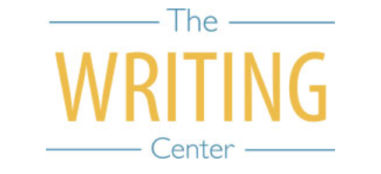 | 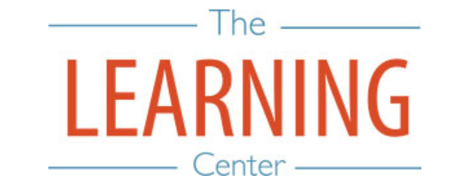

Summer Sessions I & II - 2021

Sunday Monday Tuesday Wednesday Thursday Friday Saturday
MAY | 17 | 18 | 19 SSI & Maymester Begin | 20 | 21 | 22
23 | 24 | 25 | 26 | 27 | 28 | 29
30 | 31 Holiday – No Classes | 1 JUNE | 2 | 3 Maymester Classes End | 4 Maymester Exams | 5
6 | 7 | 8 | 9 | 10 | 11 | 12
13 | 14 | 15 | 16 | 17 | 18 | 19
20 | 21 SSI Classes End | 22 SSI Reading Day | 23 SSI Exam Day | 24 SSI Exam Day | 25 | 26
27 | 28 SSII Begins | 29 | 30 | 1 JULY | 2 | 3
4 | 5 Holiday – No Classes | 6 | 7 | 8 | 9 | 10
11 | 12 | 13 | 14 | 15 | 16 | 17
18 | 19 | 20 | 21 | 22 | 23 | 24
25 | 26 | 27 | 28 | 29 SSII Classes End | 30 SSII Reading Day | 31
1 AUGUST | 2 SSII Exam Day | 3 SSII Exam Day | 4 | 5 | 6 | 7
8 | 9 | 10 | 11 | 12 | 13 | 14
15 New Student Convocation | 16 | 17 | 18 Fall Semester Begins | 19 | 20 | 21

The Writing & Learning Center / The University of North Carolina at Chapel Hill / writingcenter.unc.edu (919) 962-7710 learningcenter.unc.edu

