 | Tasks for: ________________  (class) | Tasks for: ________________  (class) | Tasks for: ________________  (class) | Tasks for: ________________  (class) | Tasks for: ________________  (class)
Wed 5/5
LDOC
Thu 5/6
Reading Day
Fri 5/7
Sat 5/8
Sun 5/9
Mon 5/10
Tue 5/11
Wed 5/12
Reading Day
Thu 5/13
Fri 5/14
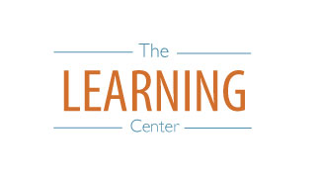
The Learning Center’s
Final Exam Master Task Table
Spring 2021
learningcenter.unc.edu https://www.facebook.com/UncChLearningCenter 919-962-3782

