 | Tasks for: ________________  (class) | Tasks for: ________________  (class) | Tasks for: ________________  (class) | Tasks for: ________________  (class) | Tasks for: ________________  (class)
Sun 11/15
Mon 11/16
Tue 11/17
Wed 11/18
Thurs 11/19
Fri 11/20
Sat 11/21
Sun 11/22
Mon 11/23
Tues 11/24
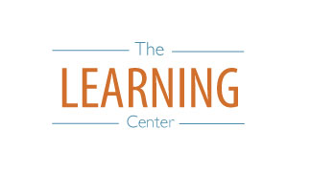
The Learning Center’s
Final Exam Master Task Table
Fall 2020
learningcenter.unc.edu https://www.facebook.com/UncChLearningCenter 919-962-3782

