 | Sun  11/15 | Mon  11/16 | Tues  11/17 | Wed  11/18 | Thurs  11/19 | Fri  11/20 | Sat  11/21 | Sun  11/22 | Mon  11/23 | Tues  11/24
8 – 9
AM
9 – 10
AM
10 – 11
AM
11 – 12
AM
12 – 1
PM
1 – 2
PM
2 – 3
PM
3– 4
PM
4 – 5
PM
5 – 6
PM
6 – 7
PM
7 – 8
PM
8 – 9
PM
9 – 10
PM
10 – 11
PM
11 – 12
PM
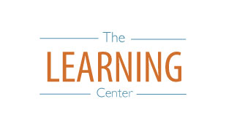
learningcenter.unc.edu https://www.facebook.com/UncChLearningCenter 919-962-3782
The Learning Center’s
Day-by-Day Final Exam Planner

