 | Tasks for: ________________  (class) | Tasks for: ________________  (class) | Tasks for: ________________  (class) | Tasks for: ________________  (class) | Tasks for: ________________  (class)
Sat 4/25
Sun 4/26
Mon 4/27
Tues 4/28
Wed 4/29
Thurs 4/30
Fri 5/1
Sat 5/2
Sun 5/3
Monday 5/4
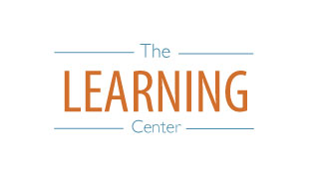
The Learning Center’s
Final Exam Master Task Table
Spring 2020
learningcenter.unc.edu https://www.facebook.com/UncChLearningCenter 919-962-3782

