 | Tasks for: ________________  (class) | Tasks for: ________________  (class) | Tasks for: ________________  (class) | Tasks for: ________________  (class) | Tasks for: ________________  (class)
Wed 12/4
Thurs 12/5
Fri 12/6
Sat 12/7
Sun 12/8
Mon 12/9
Tues 12/10
Wed 12/11
Thurs 12/12
Fri 12/13
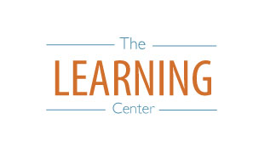
The Learning Center’s
Final Exam Master Task Table
Fall 2019
learningcenter.unc.edu https://www.facebook.com/UncChLearningCenter 919-962-3782

