 | Tasks for: ________________  (class) | Tasks for: ________________  (class) | Tasks for: ________________  (class) | Tasks for: ________________  (class) | Tasks for: ________________  (class)
Wed 12/6
Thu 12/7
Fri 12/8
Sat 12/9
Sun 12/10
Mon 12/11
Tue 12/12
Wed 12/13
Thu 12/14
Fri 12/15
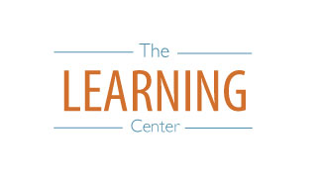
The Learning Center’s
Final Exam Master Task Table
Fall 2017
learningcenter.unc.edu https://www.facebook.com/UncChLearningCenter 919-962-3782

