 | Weds  12/6 | Thurs  12/7 | Fri  12/8 | Sat  12/9 | Sun  12/10 | Mon  12/11 | Tues  12/12 | Weds  12/13 | Thurs  12/14 | Fri  12/15
8 – 9
AM
9 – 10
AM
10 – 11
AM
11 – 12
AM
12 – 1
PM
1 – 2
PM
2 – 3
PM
3– 4
PM
4 – 5
PM
5 – 6
PM
6 – 7
PM
7 – 8
PM
8 – 9
PM
9 – 10
PM
10 – 11
PM
11 – 12
PM
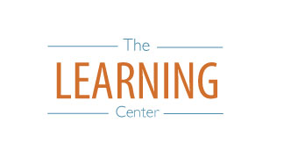
learningcenter.unc.edu https://www.facebook.com/UncChLearningCenter 919-962-3782
The Learning Center’s
Day-by-Day Final Exam Planner

